WMLC Meeting at Penn Alps, Grantsville, MD
4/11/19, 5:00pm-7:00pm
- SoMLA conference recap – Dara and Sandy presented highlights of key note speakers and small group sessions they attended
- Officer positions for next year
  - Chair – Dara McGettigan & Sandy Coluzzi
  - Vice Chair – Erica Foley
  - Secretary – VACANT
  - Treasurer – Kim Paul
  - Membership – Cheri Helmstetter
- Members should try to attend the SoMLA state meeting on June 8
- Ideas for activities for next year, approximate time frames, and locations
  - October (1st, 2nd or 3rd) – Membership kickoff: Literacy themed paint party
    - Sue Lisanti is contacting Jenny Wampler to find a place
  - October-December – Young Author’s Contest (Erica can co-chair)
  - December
    - Storybook Holiday at FSU
    - Sponsor a tree at festival of trees
    - Oakland Train Station and Penn Alps – readings to students
  - January/February meeting – PD, do ourselves or bring someone in?
    - Washington County chapter brings authors in and maybe we could go to them or have them come here
    - Contact Ali Schilpp to join – she would be a good contact for authors
  - April 1-3, 2020 SoMLA conference
  - May – spring banquet/young author’s reception; get an author as a guest speaker?
  - Outreach activities to distribute books and raise awareness of importance of reading (any time)
    - Giving away free books in Frostburg at City Place around this time every year
  - Books for Babies – update from Cheri
    - Where can we get more bibs and books?
    - Priced bibs online and cheapest were $6/piece for ordering 100 or more
    - Has enough to do one more class – next class is in June
    - Need to contact Mary Lou from SoMLA
    - Hannah from the Library – works with Garrett Hospital and may need more materials, too
  - Erica - Companies like HMH will sponsor a speaker
  - Kim – traveling trunks from Maryland Historic Society; free for Western Maryland
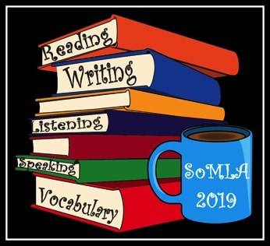
  - Erica – grant ($100) use for activities to increase membership; for membership drive (Erica emailed this info to Sandy)

